You survey households in your area to find the average rent they are paying. Find the standard deviation from the following data:

$1550, $1700, $900, $850, $1000, $950.

Code:

import pandas as pd

# Area Rent data from the given list

areaRent = [1500,1700,900,850,1000,950]

# Let the data frame be df

df = pd.DataFrame(areaRent)

display(df)

Output:

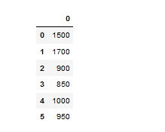

display(df.describe())

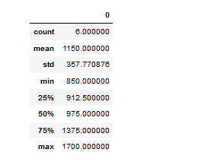

display(df.std())

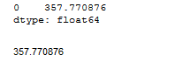

Problem Statement 2:

Find the variance for the following set of data representing trees in California (heights in

feet):

3, 21, 98, 203, 17, 9

Code:

import pandas as pd

height = [3,21,98,203,17,9]

df = pd.DataFrame(height)

df.var()

Output:

op4.PNG

df.iloc[:,0].var()

op5.PNG

Problem Statement 3:

In a class on 100 students, 80 students passed in all subjects, 10 failed in one subject, 7 failed in two subjects and 3 failed in three subjects. Find the probability distribution of the variable for number of subjects a student from the given class has failed in.

Code:

# Percentage and Probablity of the data Total Students = 100 => 100% Passed = 80 => 80% =>80/100 => 80% 0.8 Probability

# 1 Subject Failed = 10 => 10% 0.1 Probability

# 2 Subjects Failed = 7 => 7% 0.07 Probability

# 3 Subjects Failed = 3 => 3% 0.03 Probability

import numpy as np

import pandas as pd

import scipy.stats as stats

list=[0.1,0.03,0.07,0.8]

df = pd.DataFrame(list)

display(df.describe())

Output:

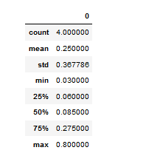

mean = 0.250000

standard_deviation = 0.367786

# For accurate values * 100

# 25.00 & 36.7786

# Cummilative Denisty Function

stats.norm(25.00,36.7786).cdf(80)

op7.PNG

# Probability Denisity Function

stats.norm(25.00,36.7786).pdf(80)

op8.PNG